***PYGG POT***

Subject: Human Computer Interface

Semester VI

Faculty – Supriya Agarwal

By

Rhea Acharya (B002) and Harshitha K(B053)

Academic year: 2018-19

1. **Introduction:**

We have undertaken a project to design an ATM interface for children and teens in the age bracket of 10-15 years.

A regular ATM can often be overwhelming to use for the first time, especially in children of the stated age group. And since it is a matter of sensitive bank and card details, it would greatly decrease the scope of crimes related to ATMs, if the users were able to use the ATM quickly and get the job done, even for first time users.

We conducted a survey to know how many children have faced difficulties in using an ATM, the results of which are given below.

1. **Problem Statement:**

“To design a touchscreen interface for an Automatic Teller Machine (ATM) geared towards kids aged 10-15 whose parents have opened a savings account for them. These ATMs will be located in public places, such as at malls. They can be used to encourage kids to save money. This new unit has touchscreen style (with multi-touch) and no physical buttons”.

1. **Project Team members and responsibilities**

Harshitha Koppisetty – Interacting with the target user group. i.e children of the ages 10-15, framing questions for the survey, designing the interface on paper, completing the report (second part) and preparing the presentation.

Rhea Acharya – Analysing results of survey and framing requirement analysis report (first part) and implementing the designed interface.

1. **Know your user:**

Who will be the user? What and how information is gathered from user? How to collect the user needs to achieve the goal? What are the psychological and ergonomic factors that should be included in interface designing?

Many users may interact with the system during its operations and maintenance, e.g. users, operators and maintenance personnel.  Certain characteristics of these people, such as educational level, language, experience and technical expertise impose important constraints on the software.

The system will be like any other ATM in terms of functionality, hence the set of people interacting with the system, in terms of maintenance, stay the same as a regular ATM. Technical expertise is necessary for maintenance of the ATM

The primary users will be children and their parents.

Basic understanding of bank and ATM functioning is essential for the user of the ATM

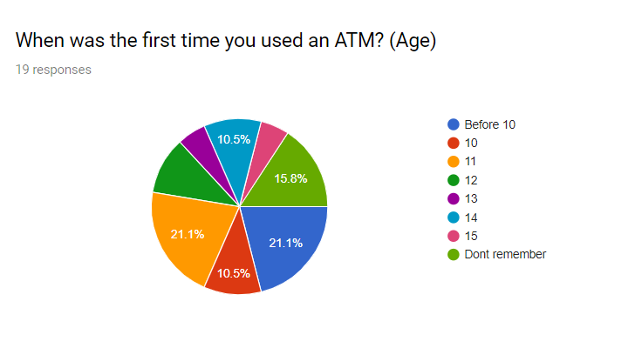

As seen in the results, a considerable number of children (21.1%) have used an ATM before the age of 10, which means that most kids in the age range 10-15 understand how an ATM works and the usage.

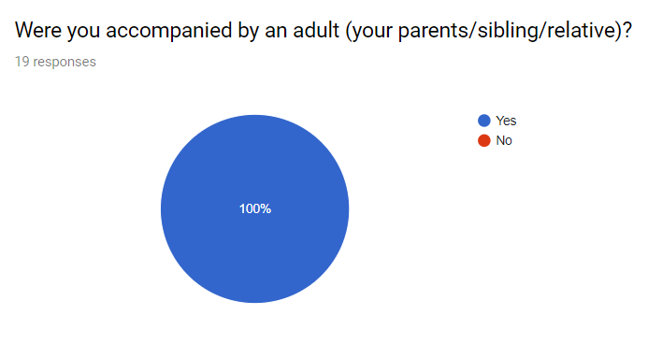

Evidently, none of the children who participated in the survey were alone the first time they used an ATM. Everyone was accompanied by an adult/elder sibling the first time using an ATM.

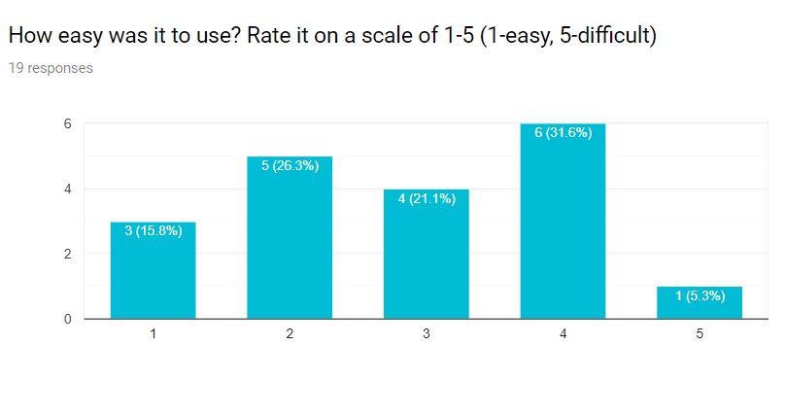

According to the survey, ease of use is an issue but it can be improved upon, compared to a regular ATM. 6 out of 19 children who took part in the survey faced moderately high difficulty in using the ATM

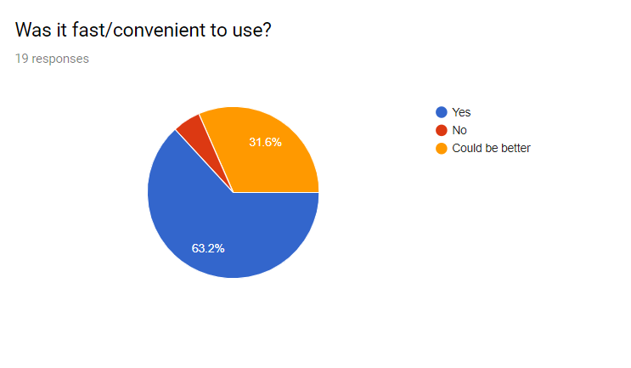

ATMs are fast and convenient to use but the convenience often depends on the knowledge of the user. Since all the children visited an ATM with an adult the first time, it would have seemed convenient since the adult would have knowledge about the functioning of the ATM.

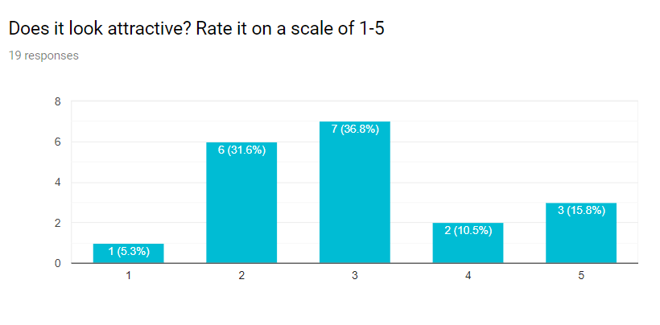

Some additional suggestions given by them included:

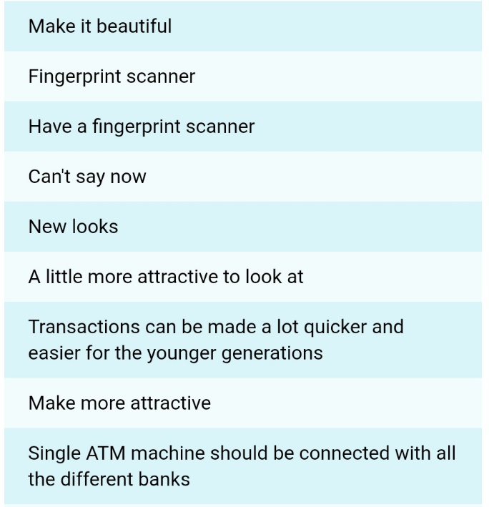

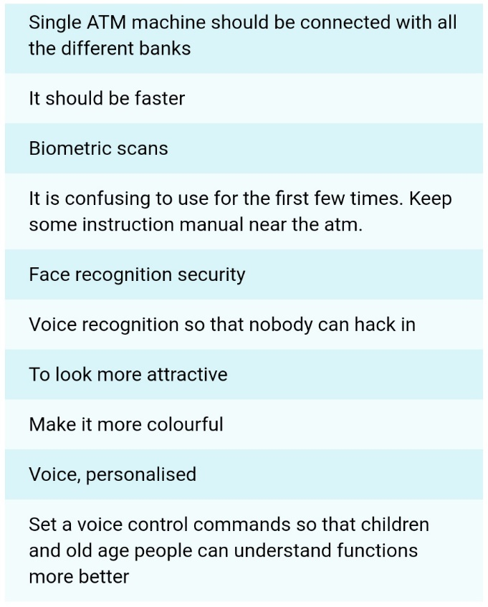

As is seen from the results of the survey, the aesthetics of the ATM system can be improved greatly. Some of the children participating in the survey suggested placing user manuals near the ATM machine to aid first time users. A few others suggested improving the appearance of the ATM interface, which will be our primary aim in the project. There also were suggestions for biometric systems for authentications, eliminating the need to remember ATM pins.

1. **Interface Requirements**
   1. **User Specification:** users need in terms of system adaptability

* User interface must be easy to navigate.
* Height must be such that the screen is visible clearly to the user.
  1. **Functional Requirements:** Describes functionality of the system. How model will work? Describe the environment in which the system is to operate.
* It is preferred that the ATM be in a residential complex with enough security for the safety of the children.
* The environment the ATM is expected to operate in is a metropolitan city- Mumbai or similar.
* Users must speak either English or Hindi

**Diagram showing flow of actions in ATM system**

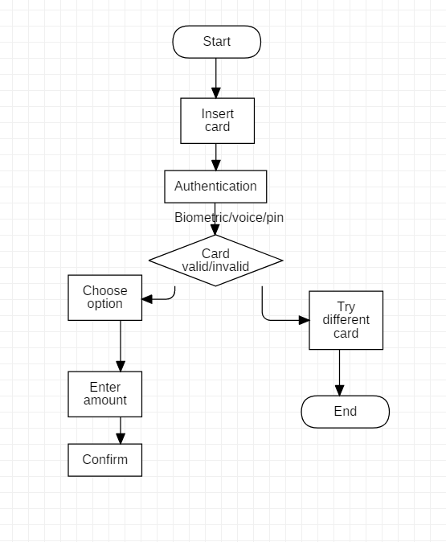

* 1. **Input/Output Devices:**

Input device: Touch screen and numpad.

Output device: Display screen, receipt and cash dispenser

* 1. **Assumptions (if any):**

It is assumed here that the internal workings of the ATM and transactions with the bank remain the same as that of any regular ATM.

The parent/guardian/primary account holder gets notified every time the child performs a transaction

Height of the ATM may required to be adjusted according to children, or a raised platform can be included.

It is assumed that the user of the ATM knows hindi or English, since the interface will be in these two languages.

As suggested by some of the children we interacted with, voice recognition or biometrics support for authentication can be included in the new ATM interface.

The user should have a card issued to their account or parents’ account

The parent can set and edit the limit, parent has access to the account via netbanking/mobile app.

1. **Designing Tool**

The designing tool used was Adobe Photoshop. The sound clips were made and downloaded from www.fromtexttospeech.com and were added using Microsoft PowerPoint.

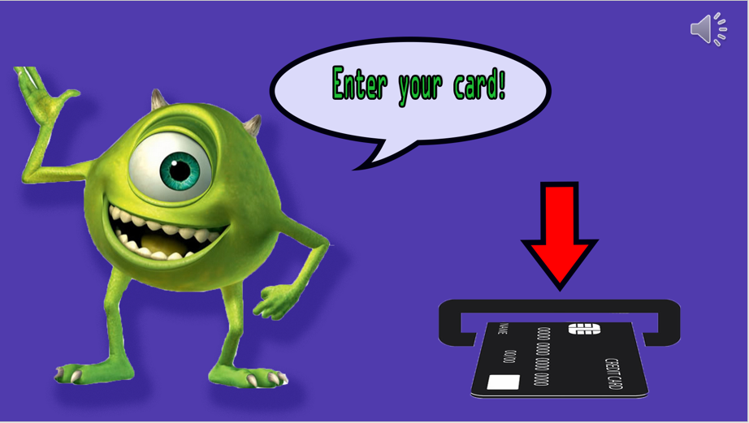 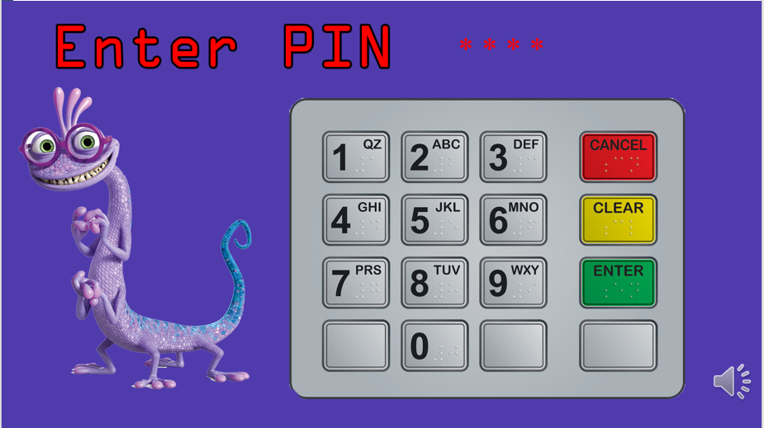

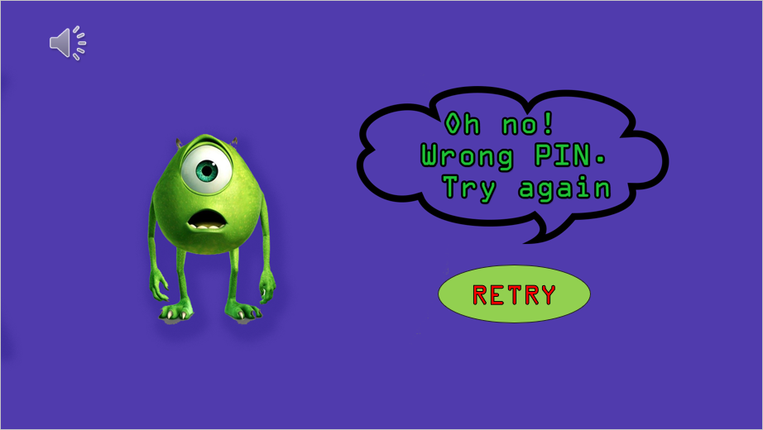 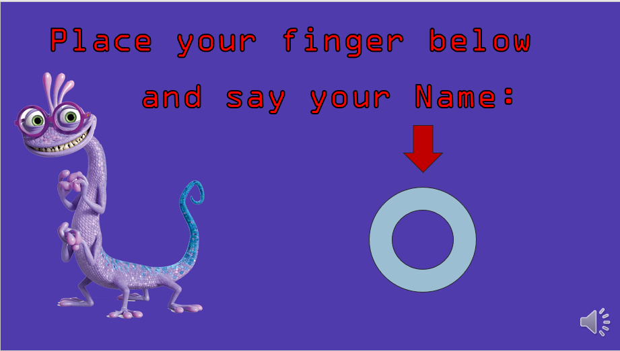

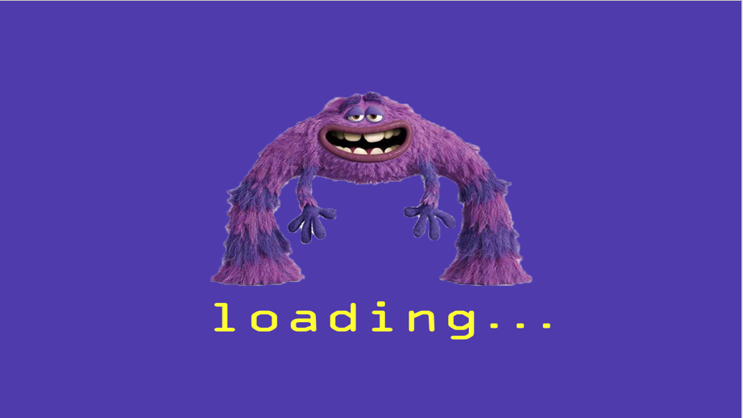 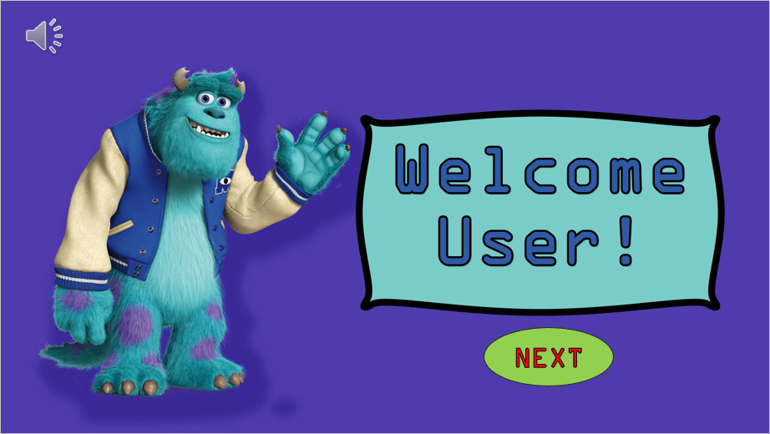

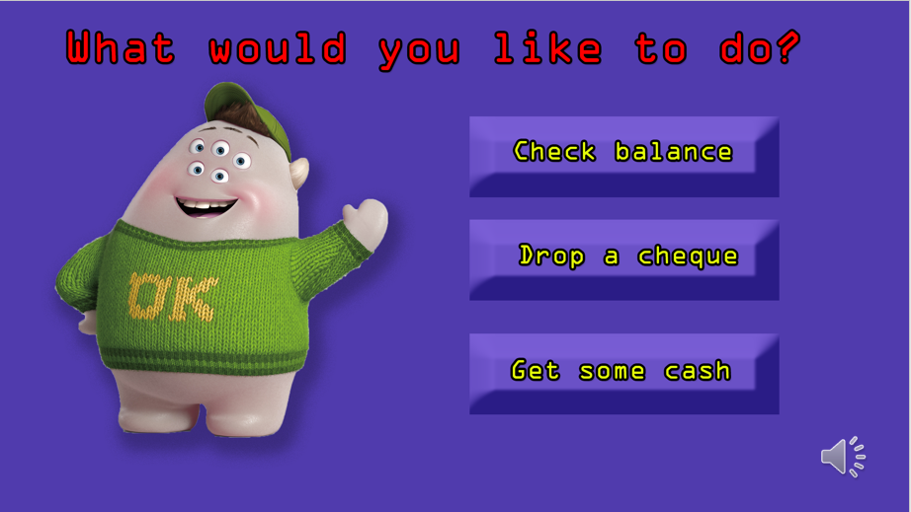 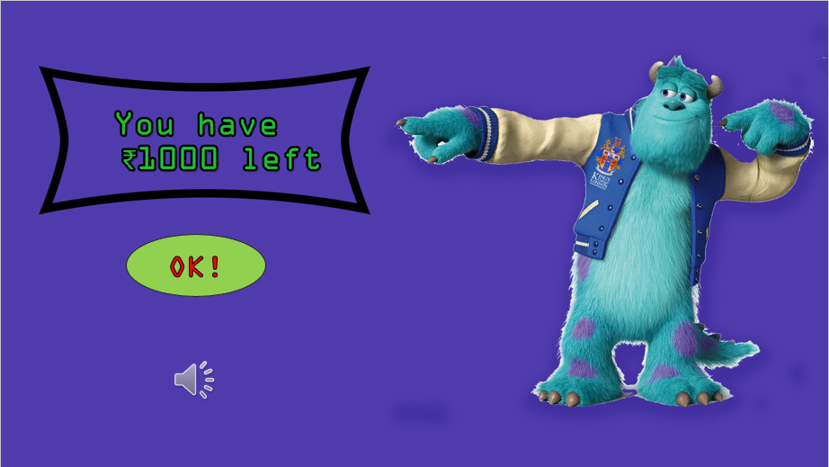

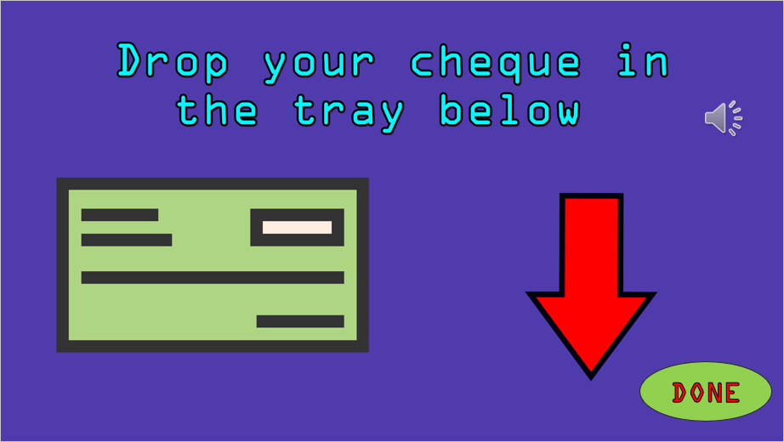 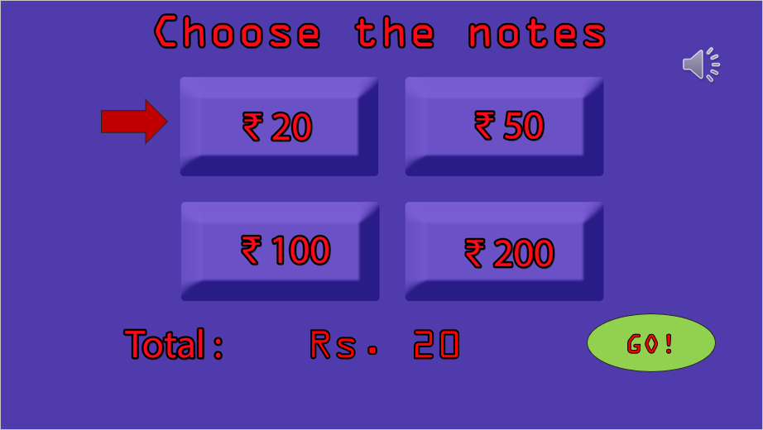

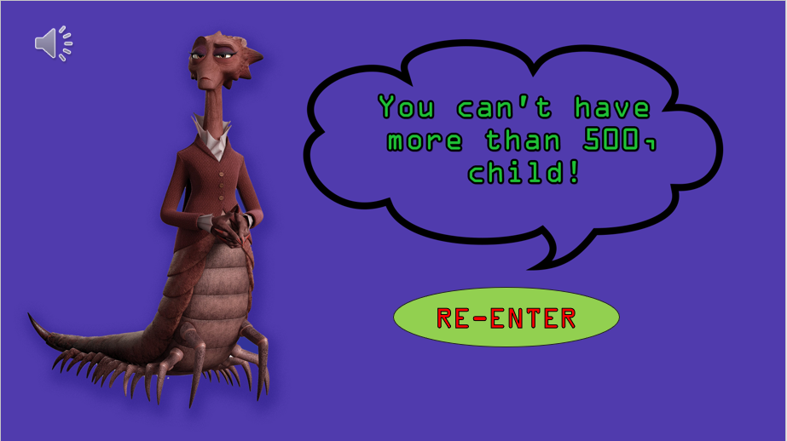 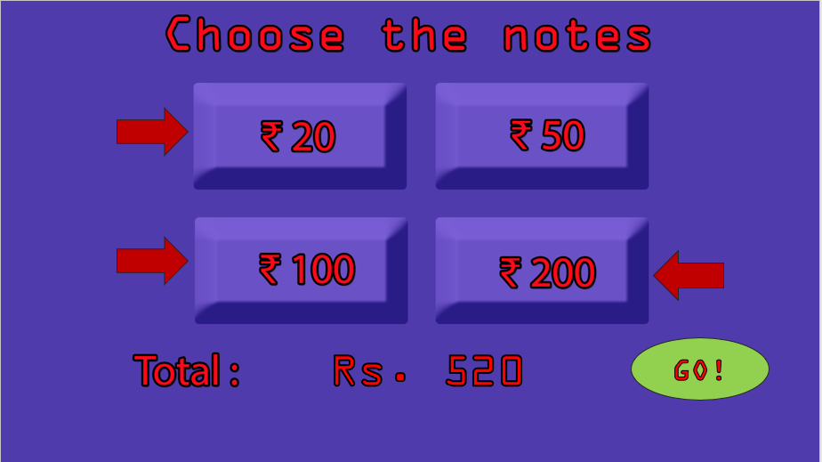

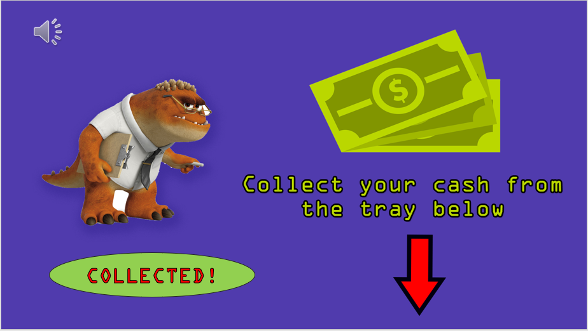 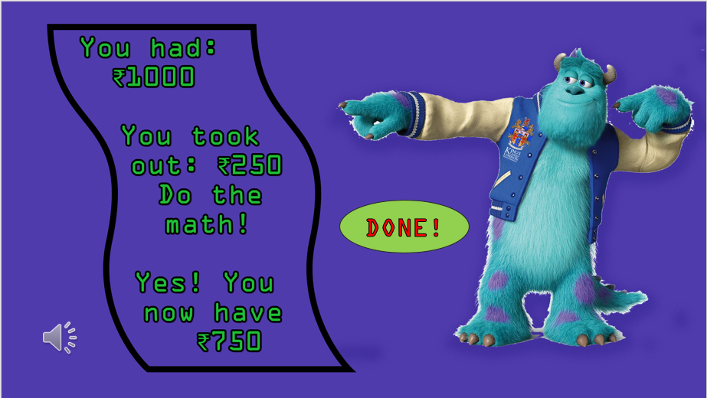

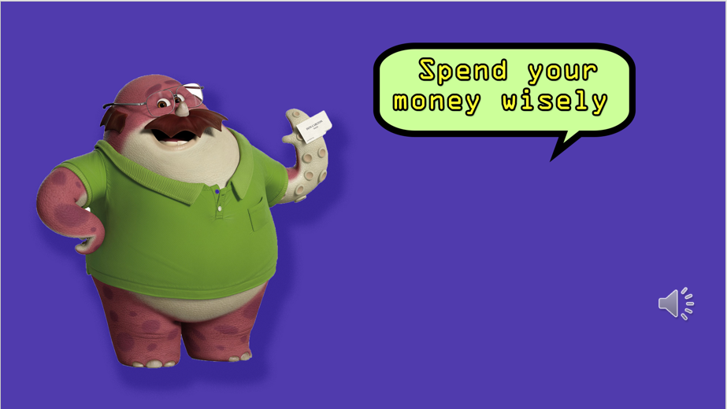 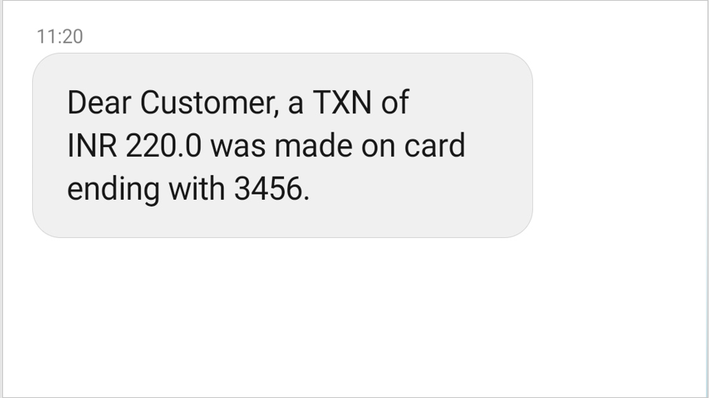

1. **Experimental Evaluation**

**User:** Children in the age group of 10-15 years.

**Variables:**

* 1. **Independent variables:** Style of the atm, number of menu items, password input type, voice guide

**Levels:** password type- PIN and Biometric, instructions type – text and speech

* 1. **Dependent variables:** the time taken to complete a task and the number of errors as a way to test learnability and usability of the interface

**Hypothesis:** “The system should be easy to utilise because of the simplified instructions delivered by both text and speech and the option to avoid remembering the PIN by using biometrics-based passwords.

**Experimental Design:** Between-groups to ensure no transfer of learning, to test how usable the system is without the need for too much training.

1. **Feedback**

We talked to Shubha Puthran Ma'am and she gave the following suggestions:

* The cheque feature is not very secure.
* The height of the screen should be adjusted for the children
* The location of the ATM should be carefully considered. It can be placed in populated, monitored areas but places where the children visit, like McDonalds or Starbucks, and not in the same place as usual ATMs because of the degree of isolation there. Those areas (McDonalds etc) are populated and more secure for the children.

We also talked to Geetanjali Gokhale Ma'am. She liked the interface but hinted that improvement was possible. Some of her suggestions were:

* The parents should get a message whenever the children access the ATM, even when dropping the cheque.
* The voice guide can be clearer, with better enunciation.